**Ideation Phase**

**Empathize & Discover**

|  |  |
| --- | --- |
| Date | 23 September 2022 |
| Team ID | PNT2022TMID47104 |
| Project Name | Project – Inventory Management System for Retailers |
| Maximum Marks | 4 Marks |

**Empathy Map Canvas:**

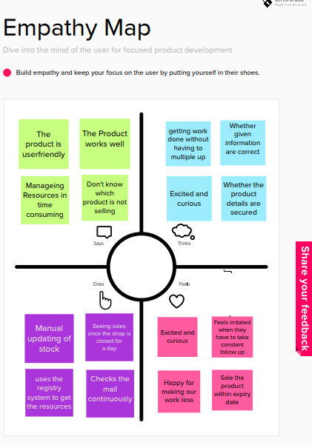

Reference: https://app.mural.co/invitation/mural/inventorysystem8245/1662990247889?sender=uc8206468e212748e2eea2294&key=b38a607b-b295-4de9-ab1d-1c6c5deba47b